# CCVG Meeting Demo Script

CCVF Database Development Team

April 8, 2020

## Function 1: Retrieve all information/data for any of singular village.

This function retrieves information/data for a village under certain selection criteria, such as altitude, rainfall, average temperature, ethnic groups or population

Example: retrieve all information about a village, such as "叶店村(Yedian village)"

SQL command:

SELECT vu.`Village Name - Chinese Characters_村名 - 汉字`, vu.`Village Name - Hanyu Pinyin_村名 - 汉语拼音`, viad.`Gazetteer Title_村志书名`, viad.`Village Code_村庄代码`, viad.`Category`, viad.`Data`, viad.`Unit`,

vill.`Category`, vill.`Data`, vill.`Unit`, neu.`Category`, neu.`Data`, neu.`Unit`,

nd.`Types of Natural Disasters_自然灾害种类`, nd.`Years_年份`,

last_name.`Total Number of Last Names in Village_姓氏总数`, last_name.`Five Most Common Last Names-Chinese Characters_前五大姓氏 - 汉字`, last_name.`Five Most Common Last Names-Hanyu Pinyin_前五大姓氏 - 汉语拼音`,

fy.`category`, fy.`year`, eyu.`Ethnic Groups_民族`, eyu.`Start Year`, eyu.`End Year`, eyu.`Data`, eyu.`Division1`,

eru.`Ethnic Groups_民族`, eru.`START YEAR`, eru.`END YEAR`, eru.`DATA`, eru.`Division1`,

pyu.`pop_category_id`, pyu.`pop_subcategory_id`, pyu.`Start Year`, pyu.`End Year`, pyu.`Data`,

pru.`pop_category_id`, pru.`pop_subcategory_id`, pru.`Start Year`, pru.`End Year`, pru.`Data`,

mru.`mi_category_id`, mru.`mi_subcategory_id`, mru.`Start Year`, mru.`End Year`, mru.`Data`,

myu.`mi_category_id`, myu.`mi_subcategory_id`, myu.`Start Year`, myu.`End Year`, myu.`Data`,

fpr.`Category`, fpr.`START YEAR`, fpr.`END YEAR`, fpr.`DATA`,

fpyu.`Category`, fpyu.`Start Year`, fpyu.`End Year`, fpyu.`Data`,

edyu.`Category`, edyu.`Subcategory`, edyu.`Start Year`, edyu.`End Year`, edyu.`Data`,

edru.`edu_category_id`, edru.`edu_subcategory_id`, edru.`Start Year`, edru.`End Year`, edru.`Data`,

ecoru.`eco_category_id`, ecoru.`eco_subcategory_id`, ecoru.`START YEAR`, ecoru.`END YEAR`, ecoru.`Data`, ecoru.`Unit`

FROM village_updated vu

LEFT JOIN village_information_area_and_distance viad ON vu.`g_id` = viad.`g_id`

LEFT JOIN village_information_long_and_lati vill ON vu.`g_id` = vill.`g_id`

LEFT JOIN natural_environment_updated neu ON vu.`g_id` = neu.`g_id`

LEFT JOIN natural_disasters nd ON vu.`g_id` = nd.`Gazetteer Code_村志代码`

LEFT JOIN last_name ON vu.`g_id` = last_name.`Gazetteer Code_村志代码`

LEFT JOIN update_year_of_first_availability_or_purchase fy ON vu.`g_id` = fy.`g_id`

LEFT JOIN ethnic_yearly_updated eyu ON vu.`g_id` = eyu.`g_id`

LEFT JOIN ethnic_range_updated eru ON vu.`g_id` = eru.`g_id`

LEFT JOIN population_yearly_updated pyu ON vu.`g_id` = pyu.`g_id`

LEFT JOIN population_range_updated pru ON vu.`g_id` = pru.`g_id`

LEFT JOIN military_range_updated mru ON vu.`g_id` = mru.`g_id`

LEFT JOIN military_year_final_updated myu ON vu.`g_id` = myu.`g_id`

LEFT JOIN family_planning_range fpr ON vu.`g_id` = fpr.`g_id`

LEFT JOIN family_planning_yearly_updated fpyu ON vu.`g_id` = fpyu.`g_id`

LEFT JOIN education_yearly_updated edyu ON vu.`g_id` = edyu.`g_id`

LEFT JOIN education_range_updated edru ON vu.`g_id` = edru.`g_id`

LEFT JOIN economy_range_updated ecoru ON vu.`g_id` = ecoru.`g_id`

WHERE vu.`Village Name - Chinese Characters_村名 - 汉字` = '叶店村';

Output Table:

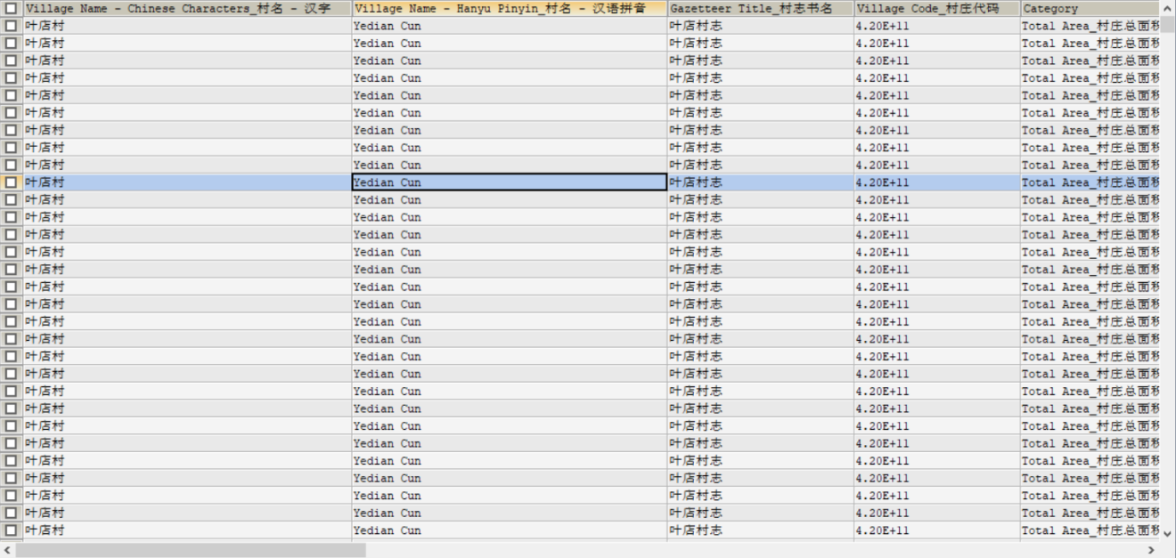

Issues to be discussed:

When users query all information about one given village, the combination of 20 tables is very large and there are tons of duplicate values in the result, just as the picture shows.

Possible solution: divide tables related to one village into several groups:

*Group 1*: Village information and natural environment(village information, natural environment, natural disasters)

SELECT vu.`Village Name - Chinese Characters_村名 - 汉字`, vu.`Village Name - Hanyu Pinyin_村名 - 汉语拼音`,

viad.`Village Code_村庄代码`, viad.`Category`, viad.`Data`, viad.`Unit`,

vill.`Category`, vill.`Data`, vill.`Unit`,

neu.`Category`, neu.`Data`, neu.`Unit`,

nd.`Types of Natural Disasters_自然灾害种类`, nd.`Years_年份`

FROM village_updated vu

LEFT JOIN village_information_area_and_distance viad ON vu.`g_id` = viad.`g_id`

LEFT JOIN village_information_long_and_lati vill ON vu.`g_id` = vill.`g_id`

LEFT JOIN natural_environment_updated neu ON vu.`g_id` = neu.`g_id`

LEFT JOIN natural_disasters nd ON vu.`g_id` = nd.`Gazetteer Code_村志代码`

WHERE vu.`Village Name - Chinese Characters_村名 - 汉字` = '叶店村';

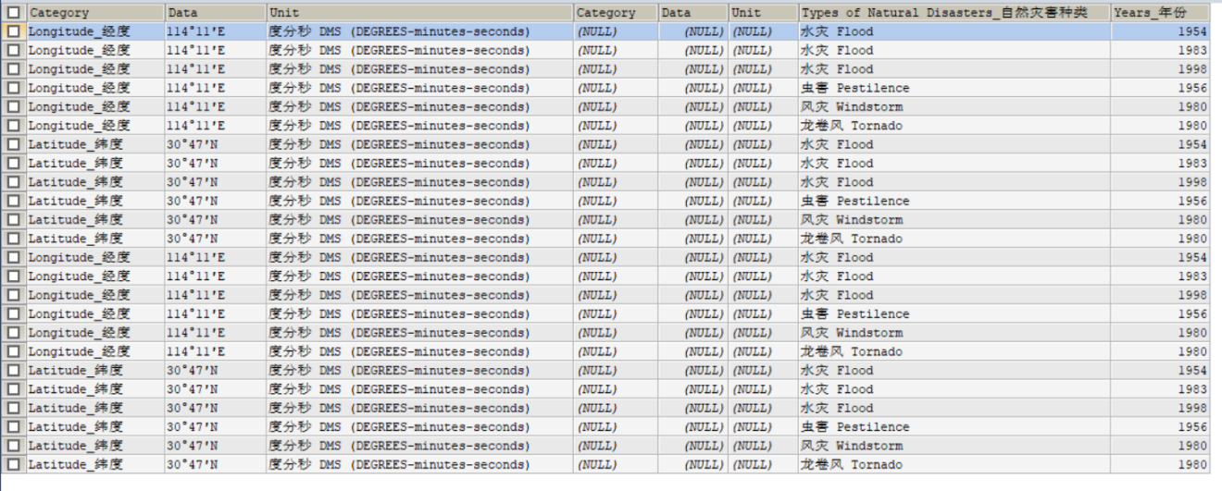

*Group 2*: Economics and Development(First year and economy)

SELECT vu.`Village Name - Chinese Characters_村名 - 汉字`, fyap.`category`, fyap.`year`,

ecoru.`eco_category_id`, ecoru.`START YEAR`, ecoru.`END YEAR`, ecoru.`Data`, ecoru.`Unit`

FROM village_updated vu

LEFT JOIN update_year_of_first_availability_or_purchase fyap ON vu.`g_id` = fyap.`g_id`

LEFT JOIN economy_range_updated ecoru ON vu.`g_id` = ecoru.`g_id`

WHERE vu.`Village Name - Chinese Characters_村名 - 汉字` = '叶店村';

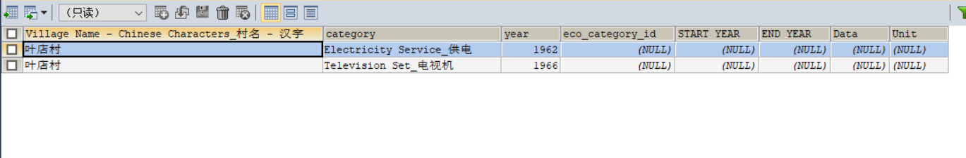

*Group 3*: Population(last names, ethnics, population, family planning)

SELECT vu.`Village Name - Chinese Characters_村名 - 汉字`, last_name.`Total Number of Last Names in Village_姓氏总数`, last_name.`Five Most Common Last Names-Chinese Characters_前五大姓氏 - 汉字`, last_name.`Five Most Common Last Names-Hanyu Pinyin_前五大姓氏 - 汉语拼音`,

eyu.`Ethnic Groups_民族`, eyu.`Start Year`, eyu.`End Year`, eyu.`Data`, eyu.`Division1`,

eru.`Ethnic Groups_民族`, eru.`START YEAR`, eru.`END YEAR`, eru.`DATA`, eru.`Division1`,

pyu.`pop_category_id`, pyu.`pop_subcategory_id`, pyu.`Start Year`, pyu.`End Year`, pyu.`Data`,

pru.`pop_category_id`, pru.`pop_subcategory_id`, pru.`Start Year`, pru.`End Year`, pru.`Data`,

fpy.`Category`, fpy.`START YEAR`, fpy.`END YEAR`, fpy.`DATA`,

fpr.`Category`, fpr.`Start Year`, fpr.`End Year`, fpr.`Data`

FROM village_updated vu

LEFT JOIN last_name ON vu.`g_id` = last_name.`Gazetteer Code_村志代码`

LEFT JOIN ethnic_yearly_updated eyu ON vu.`g_id` = eyu.`g_id`

LEFT JOIN ethnic_range_updated eru ON vu.`g_id` = eru.`g_id`

LEFT JOIN population_yearly_updated pyu ON vu.`g_id` = pyu.`g_id`

LEFT JOIN population_range_updated pru ON vu.`g_id` = pru.`g_id`

LEFT JOIN family_planning_range fpr ON vu.`g_id` = fpr.`g_id`

LEFT JOIN family_planning_yearly_updated fpy ON vu.`g_id` = fpy.`g_id`

WHERE vu.`Village Name - Chinese Characters_村名 - 汉字` = '叶店村';

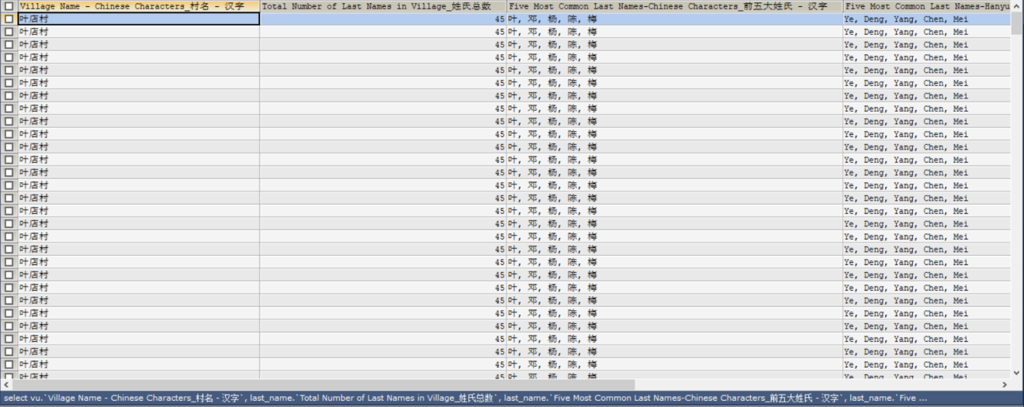

*Group 4*: Military, politics and management(Military)

SELECT vu.`Village Name - Chinese Characters_村名 - 汉字`, mru.`mi_category_id`, mru.`mi_subcategory_id`, mru.`Start Year`, mru.`End Year`, mru.`Data`,

myu.`mi_category_id`, myu.`mi_subcategory_id`, myu.`Start Year`, myu.`End Year`, myu.`Data`

FROM village_updated vu

LEFT JOIN military_range_updated mru ON vu.`g_id` = mru.`g_id`

LEFT JOIN military_year_final_updated myu ON vu.`g_id` = myu.`g_id`

WHERE vu.`Village Name - Chinese Characters_村名 - 汉字` = '叶店村';



*Group 5*: Education(education)

(It is not obvious to use ‘叶店村’, so I decided to use ‘新立村’ to show the difference)

SELECT vu.`Village Name - Chinese Characters_村名 - 汉字`, eyu.`Category`, eyu.`Subcategory`, eyu.`Start Year`, eyu.`End Year`, eyu.`Data`

FROM village_updated vu

INNER JOIN education_yearly_updated eyu ON vu.`g_id` = eyu.`g_id`

WHERE vu.`Village Name - Chinese Characters_村名 - 汉字` = '新立村'

UNION

SELECT vu.`Village Name - Chinese Characters_村名 - 汉字`, eru.`edu_category_id`, eru.`edu_subcategory_id`, eru.`Start Year`, eru.`End Year`, eru.`Data`

FROM village_updated vu

INNER JOIN education_range_updated eru ON vu.`g_id` = eru.`g_id`

WHERE vu.`Village Name - Chinese Characters_村名 - 汉字` = '新立村';

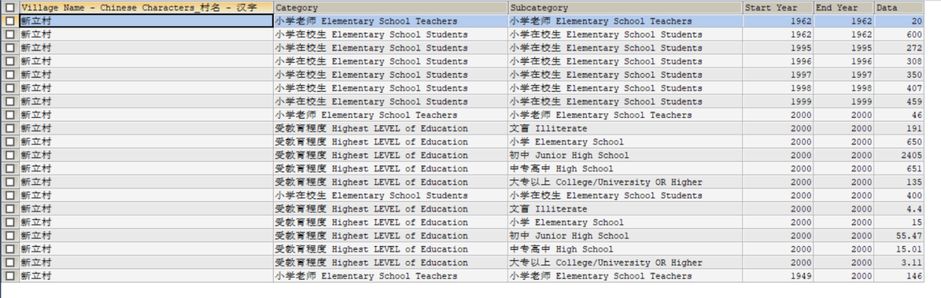

## 2. Compare information/data betweentwo village

Example: compare the information betweenvillage 万秀村and village叶店村

SELECT vu.`Village Name - Chinese Characters_村名 - 汉字`, eyu.`Category`, eyu.`Subcategory`, eyu.`Start Year`, eyu.`End Year`, eyu.`Data`

FROM village_updated vu

INNER JOIN education_yearly_updated eyu ON vu.`g_id` = eyu.`g_id`

WHERE vu.`Village Name - Chinese Characters_村名 - 汉字` = '叶店村'

UNION

SELECT vu.`Village Name - Chinese Characters_村名 - 汉字`, eru.`edu_category_id`, eru.`edu_subcategory_id`, eru.`Start Year`, eru.`End Year`, eru.`Data`

FROM village_updated vu

INNER JOIN education_range_updated eru ON vu.`g_id` = eru.`g_id`

WHERE vu.`Village Name - Chinese Characters_村名 - 汉字` = '叶店村'

UNION

SELECT vu.`Village Name - Chinese Characters_村名 - 汉字`, eyu.`Category`, eyu.`Subcategory`, eyu.`Start Year`, eyu.`End Year`, eyu.`Data`

FROM village_updated vu

INNER JOIN education_yearly_updated eyu ON vu.`g_id` = eyu.`g_id`

WHERE vu.`Village Name - Chinese Characters_村名 - 汉字` = '万秀村'

UNION

SELECT vu.`Village Name - Chinese Characters_村名 - 汉字`, eru.`edu_category_id`, eru.`edu_subcategory_id`, eru.`Start Year`, eru.`End Year`, eru.`Data`

FROM village_updated vu

INNER JOIN education_range_updated eru ON vu.`g_id` = eru.`g_id`

WHERE vu.`Village Name - Chinese Characters_村名 - 汉字` = '万秀村';

Output Table:

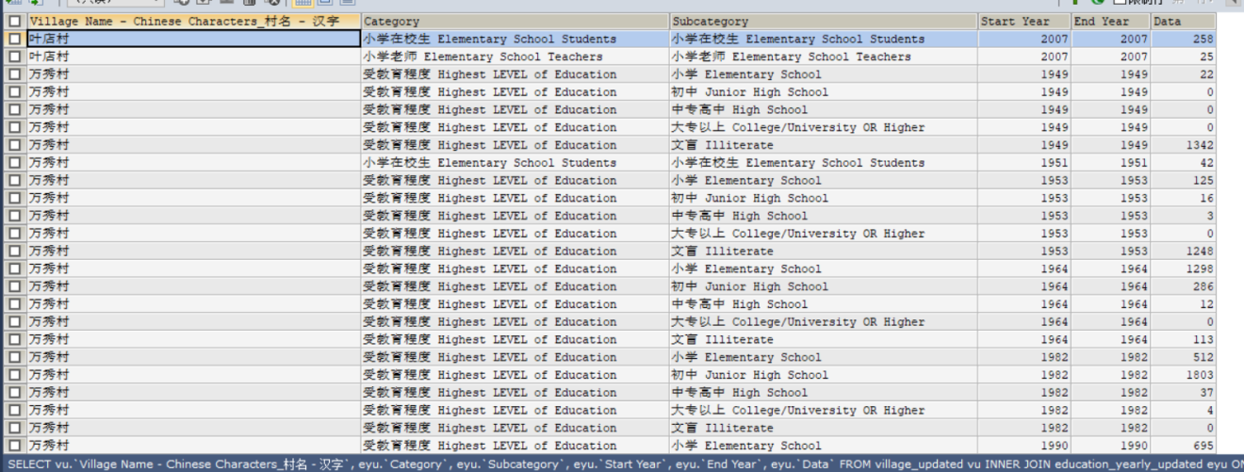

## Retrieve information/data for all villages within acounty, city or province

Example: Retrieve information from all villages(divide tables related to one village into several groups) within Shanghai City.

SQL command(Retrieve all village information and natural environment data within Shanghai City)

SELECT vu.`Village Name - Chinese Characters_村名 - 汉字`, vu.`Village Name - Hanyu Pinyin_村名 - 汉语拼音`,

viad.`Village Code_村庄代码`, viad.`Category`, viad.`Data`, viad.`Unit`,

vill.`Category`, vill.`Data`, vill.`Unit`,

neu.`Category`, neu.`Data`, neu.`Unit`,

nd.`Types of Natural Disasters_自然灾害种类`, nd.`Years_年份`

FROM village_updated vu

LEFT JOIN village_information_area_and_distance viad ON vu.`g_id` = viad.`g_id`

LEFT JOIN village_information_long_and_lati vill ON vu.`g_id` = vill.`g_id`

LEFT JOIN natural_environment_updated neu ON vu.`g_id` = neu.`g_id`

LEFT JOIN natural_disasters nd ON vu.`g_id` = nd.`Gazetteer Code_村志代码`

WHERE vu.`Village Name - Chinese Characters_村名 - 汉字` = ANY(

SELECT vu.`Village Name - Chinese Characters_村名 - 汉字`

FROM village_updated vu

INNER JOIN province_village pv ON pv.`v_id` = vu.`village_id`

INNER JOIN province p ON pv.`p_id` = p.`province_id`

WHERE p.`Province - Chinese Characters_省 - 汉字` = '上海市'

);

Output Table

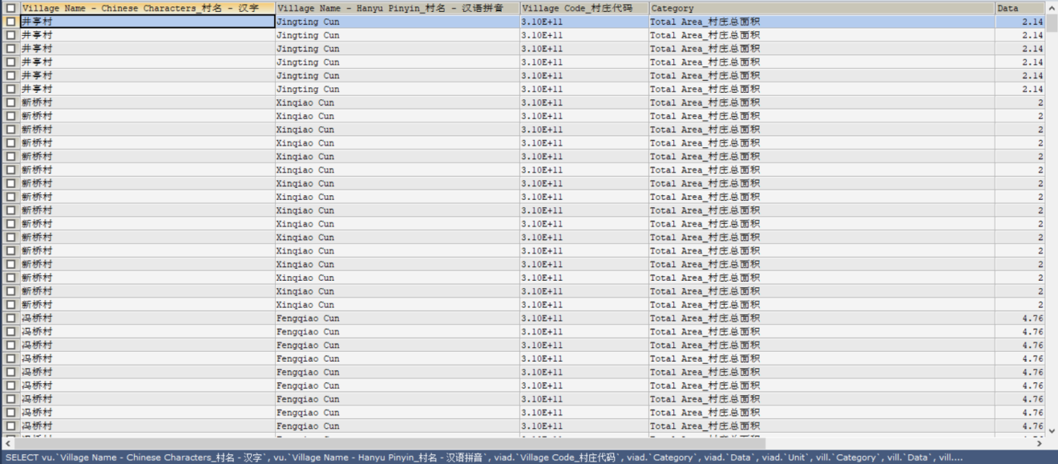

SQL command(Retrieve all Economics and Development data within Shanghai City)

SELECT vu.`Village Name - Chinese Characters_村名 - 汉字`, fyap.`category`, fyap.`year`,

ecoru.`eco_category_id`, ecoru.`START YEAR`, ecoru.`END YEAR`, ecoru.`Data`, ecoru.`Unit`

FROM village_updated vu

LEFT JOIN update_year_of_first_availability_or_purchase fyap ON vu.`g_id` = fyap.`g_id`

LEFT JOIN economy_range_updated ecoru ON vu.`g_id` = ecoru.`g_id`

WHERE vu.`Village Name - Chinese Characters_村名 - 汉字` = ANY(

SELECT vu.`Village Name - Chinese Characters_村名 - 汉字`

FROM village_updated vu

INNER JOIN province_village pv ON pv.`v_id` = vu.`village_id`

INNER JOIN province p ON pv.`p_id` = p.`province_id`

WHERE p.`Province - Chinese Characters_省 - 汉字` = '上海市'

);

Output table

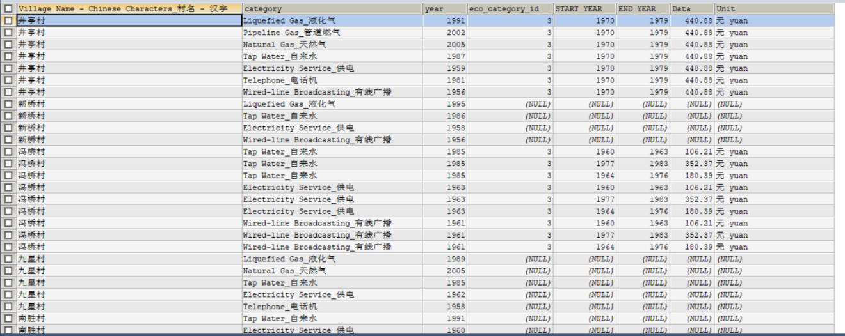

Example: list the top ranked provinces, cities, counties and villages where the number of people with the last name “Zhao” 赵

SELECT p.`Province - Chinese Characters_省 - 汉字`, c.`City - Chinese Characters_市 - 汉字`, co.`County / District - Chinese Characters_县 / 区 - 汉字`,

vu.`Village Name - Chinese Characters_村名 - 汉字`, last_name.`Total Number of Last Names in Village_姓氏总数`,

last_name.`Five Most Common Last Names-Chinese Characters_前五大姓氏 - 汉字`, last_name.`Five Most Common Last Names-Hanyu Pinyin_前五大姓氏 - 汉语拼音`

FROM last_name

INNER JOIN village_updated vu ON vu.`g_id` = last_name.`Gazetteer Code_村志代码`

INNER JOIN village_county_city_province vccp ON vccp.`v_id` = vu.`village_id`

INNER JOIN county co ON co.`county_id` = vccp.`co_id`

INNER JOIN city c ON c.`city_id` = vccp.`c_id`

INNER JOIN province p ON p.`province_id` = vccp.`p_id`

WHERE last_name.`Five Most Common Last Names-Chinese Characters_前五大姓氏 - 汉字` LIKE "%赵%"

ORDER BY last_name.`Total Number of Last Names in Village_姓氏总数` DESC;

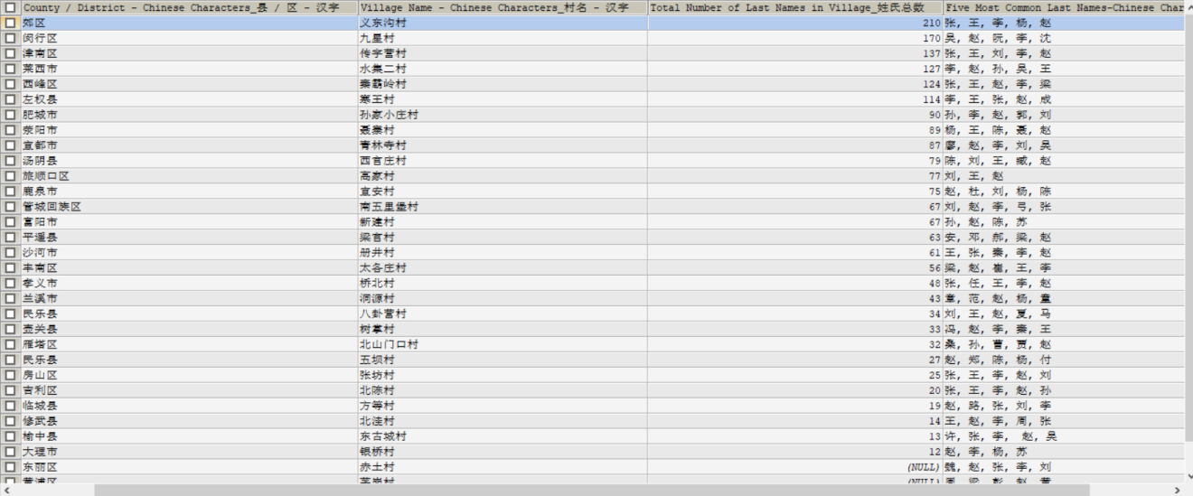

Example: list the provinces, cities, counties and villages where the ethnic groups has Hui

SELECT p.`Province - Chinese Characters_省 - 汉字`, c.`City - Chinese Characters_市 - 汉字`, co.`County / District - Chinese Characters_县 / 区 - 汉字`, vu.`Village Name - Chinese Characters_村名 - 汉字`,

eyu.`Ethnic Groups_民族`

FROM ethnic_yearly_updated eyu

INNER JOIN village_updated vu ON vu.`g_id` = eyu.`g_id`

INNER JOIN village_county_city_province vccp ON vccp.`v_id` = vu.`village_id`

INNER JOIN county co ON co.`county_id` = vccp.`co_id`

INNER JOIN city c ON c.`city_id` = vccp.`c_id`

INNER JOIN province p ON p.`province_id` = vccp.`p_id`

WHERE eyu.`Ethnic Groups_民族` = '回族 Hui'

GROUP BY vu.`Village Name - Chinese Characters_村名 - 汉字`;

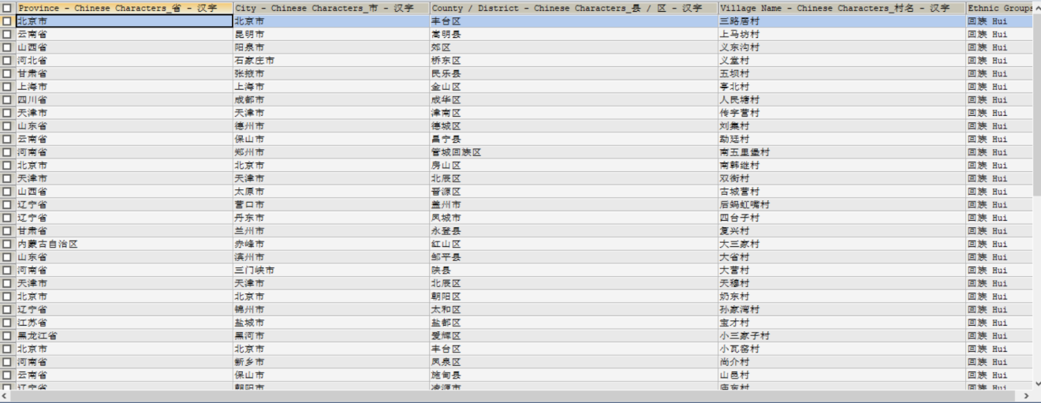

Example: list all population numbers in villages belong to Shanghai

SELECT vu.`Village Name - Chinese Characters_村名 - 汉字`, pyu.`pop_category_id`, pyu.`pop_subcategory_id`, pyu.`Start Year`, pyu.`End Year`, pyu.`Data`

FROM village_updated vu

INNER JOIN population_yearly_updated pyu ON vu.`g_id` = pyu.`g_id`

WHERE pyu.`pop_category_id` = '人口 Population'

AND vu.`Village Name - Chinese Characters_村名 - 汉字` = ANY(

SELECT vu.`Village Name - Chinese Characters_村名 - 汉字`

FROM village_updated vu

INNER JOIN province_village pv ON pv.`v_id` = vu.`village_id`

INNER JOIN province p ON pv.`p_id` = p.`province_id`

WHERE p.`Province - Chinese Characters_省 - 汉字` = '上海市'

)

UNION

SELECT vu.`Village Name - Chinese Characters_村名 - 汉字`, pru.`pop_category_id`, pru.`pop_subcategory_id`, pru.`Start Year`, pru.`End Year`, pru.`Data`

FROM village_updated vu

INNER JOIN population_range_updated pru ON vu.`g_id` = pru.`g_id`

WHERE pru.`pop_category_id` = '人口 Population'

AND vu.`Village Name - Chinese Characters_村名 - 汉字` = ANY(

SELECT vu.`Village Name - Chinese Characters_村名 - 汉字`

FROM village_updated vu

INNER JOIN province_village pv ON pv.`v_id` = vu.`village_id`

INNER JOIN province p ON pv.`p_id` = p.`province_id`

WHERE p.`Province - Chinese Characters_省 - 汉字` = '上海市'

);

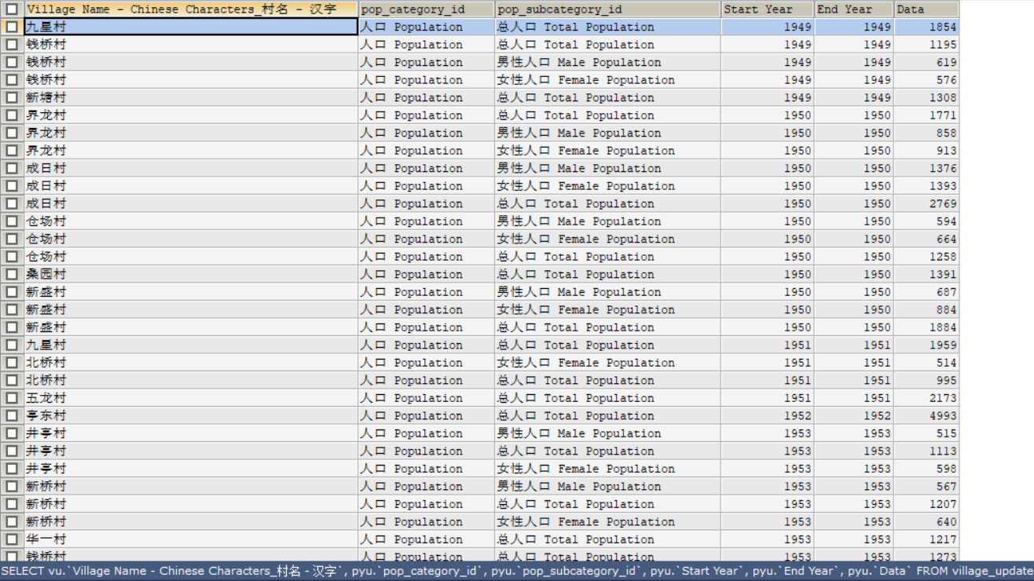

## Compare villages based on their subcategory data

Example: comparing village新立村and village插旗山村in terms of their total population

SELECT vu.`Village Name - Chinese Characters_村名 - 汉字`, pyu.`pop_category_id`, pyu.`pop_subcategory_id`, pyu.`Start Year`, pyu.`End Year`, pyu.`Data`

FROM village_updated vu

INNER JOIN population_yearly_updated pyu ON vu.`g_id` = pyu.`g_id`

WHERE vu.`Village Name - Chinese Characters_村名 - 汉字` = '新立村'

AND pyu.`pop_subcategory_id` = '总人口 Total Population'

GROUP BY pyu.`Start Year`

UNION

SELECT vu.`Village Name - Chinese Characters_村名 - 汉字`, pru.`pop_category_id`, pru.`pop_subcategory_id`, pru.`Start Year`, pru.`End Year`, pru.`Data`

FROM village_updated vu

INNER JOIN population_range_updated pru ON vu.`g_id` = pru.`g_id`

WHERE vu.`Village Name - Chinese Characters_村名 - 汉字` = '新立村'

AND pru.`pop_subcategory_id` = '总人口 Total Population'

GROUP BY pru.`Start Year`

UNION

SELECT vu.`Village Name - Chinese Characters_村名 - 汉字`, pyu.`pop_category_id`, pyu.`pop_subcategory_id`, pyu.`Start Year`, pyu.`End Year`, pyu.`Data`

FROM village_updated vu

INNER JOIN population_yearly_updated pyu ON vu.`g_id` = pyu.`g_id`

WHERE vu.`Village Name - Chinese Characters_村名 - 汉字` = '插旗山村'

AND pyu.`pop_subcategory_id` = '总人口 Total Population'

GROUP BY pyu.`Start Year`

UNION

SELECT vu.`Village Name - Chinese Characters_村名 - 汉字`, pru.`pop_category_id`, pru.`pop_subcategory_id`, pru.`Start Year`, pru.`End Year`, pru.`Data`

FROM village_updated vu

INNER JOIN population_range_updated pru ON vu.`g_id` = pru.`g_id`

WHERE vu.`Village Name - Chinese Characters_村名 - 汉字` = '插旗山村'

AND pru.`pop_subcategory_id` = '总人口 Total Population'

GROUP BY pru.`Start Year`;

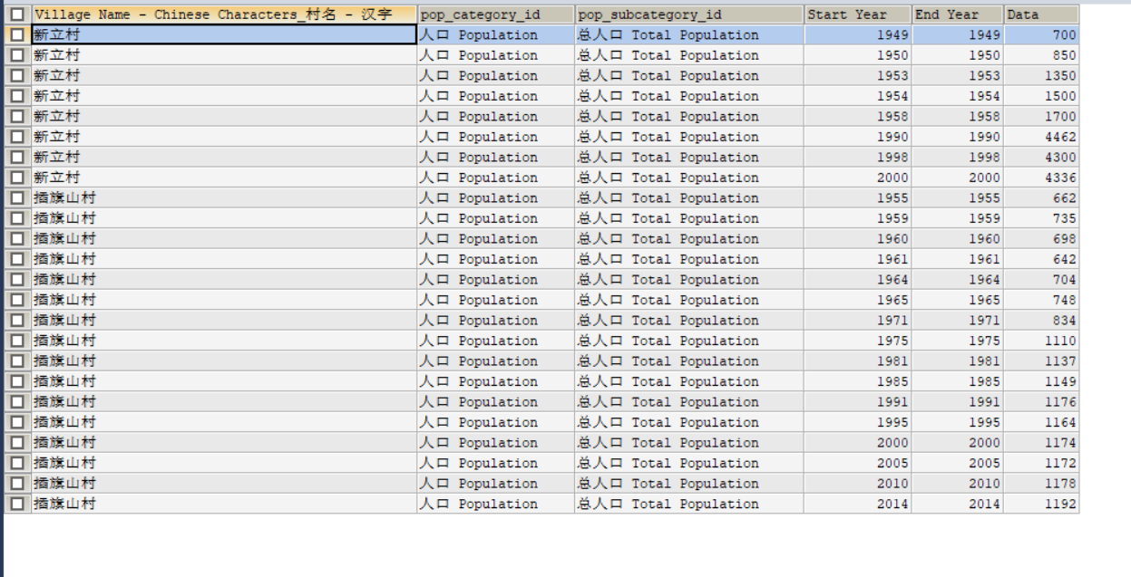

Example: List villages that are in the same altitude(one condition)

SELECT vu1.`Village Name - Chinese Characters_村名 - 汉字`, vu2.`Village Name - Chinese Characters_村名 - 汉字`, ne1.`Altitude_海拔(米)`

FROM natural_environment ne1

INNER JOIN natural_environment ne2

ON ne1.`Altitude_海拔(米)` = ne2.`Altitude_海拔(米)`

AND ne1.`Gazetteer Code_村志代码` < ne2.`Gazetteer Code_村志代码`

INNER JOIN village_updated vu1 ON vu1.`g_id` = ne1.`Gazetteer Code_村志代码`

INNER JOIN village_updated vu2 ON vu2.`g_id` = ne2.`Gazetteer Code_村志代码`;

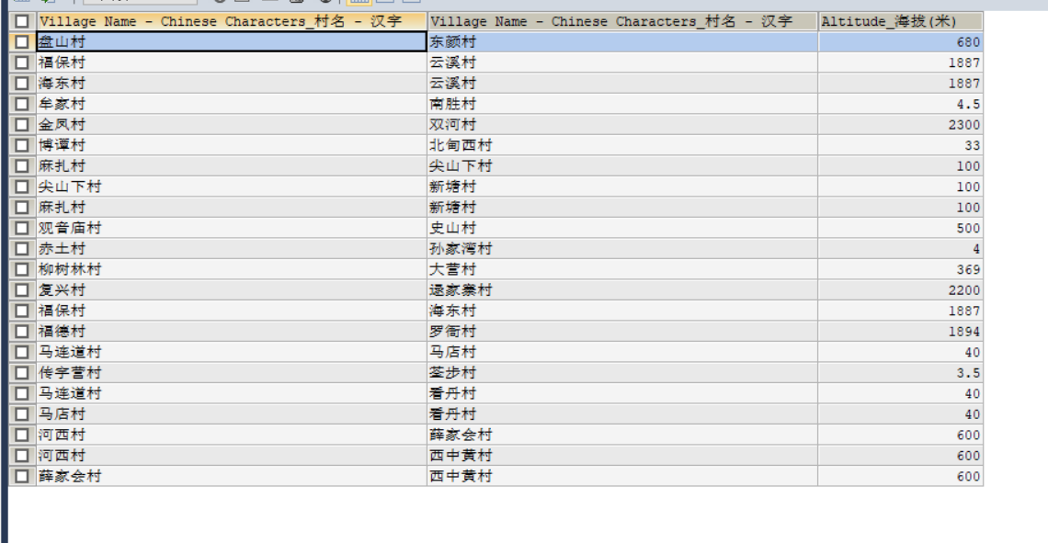

Example: List villages that are have the same average yearly temperature and same altitude(two conditions)

SELECT vu1.`Village Name - Chinese Characters_村名 - 汉字`, vu2.`Village Name - Chinese Characters_村名 - 汉字`, ne1.`Altitude_海拔(米)`, ne1.`Average Yearly Temperature_平均温度`, ne1.`Average Yearly Precipitation Amount_平均降水量`

FROM natural_environment ne1

INNER JOIN natural_environment ne2

ON ne1.`Altitude_海拔(米)` = ne2.`Altitude_海拔(米)`

AND ne1.`Average Yearly Temperature_平均温度` = ne2.`Average Yearly Temperature_平均温度`

AND ne1.`Gazetteer Code_村志代码` < ne2.`Gazetteer Code_村志代码`

INNER JOIN village_updated vu1 ON vu1.`g_id` = ne1.`Gazetteer Code_村志代码`

INNER JOIN village_updated vu2 ON vu2.`g_id` = ne2.`Gazetteer Code_村志代码`;

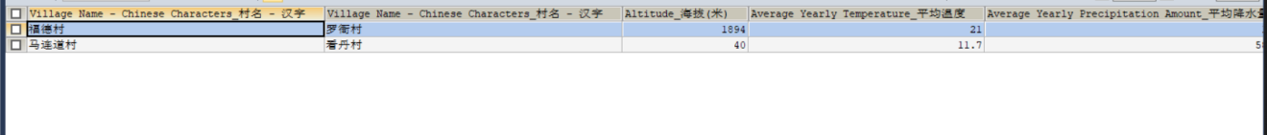

Example: List villages that are in the same altitude, the same average yearly precipitation amount and the same average yearly temperature(three conditions)

SELECT vu1.`Village Name - Chinese Characters_村名 - 汉字`, vu2.`Village Name - Chinese Characters_村名 - 汉字`, ne1.`Altitude_海拔(米)`, ne1.`Average Yearly Precipitation Amount_平均降水量`, ne1.`Average Yearly Temperature_平均温度`

FROM natural_environment ne1

INNER JOIN natural_environment ne2

ON ne1.`Altitude_海拔(米)` = ne2.`Altitude_海拔(米)`

AND ne1.`Average Yearly Precipitation Amount_平均降水量` = ne2.`Average Yearly Precipitation Amount_平均降水量`

AND ne1.`Average Yearly Temperature_平均温度` = ne2.`Average Yearly Temperature_平均温度`

AND ne1.`Gazetteer Code_村志代码` < ne2.`Gazetteer Code_村志代码`

INNER JOIN village_updated vu1 ON vu1.`g_id` = ne1.`Gazetteer Code_村志代码`

INNER JOIN village_updated vu2 ON vu2.`g_id` = ne2.`Gazetteer Code_村志代码`;

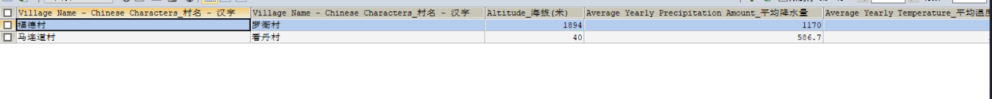

## Select year or year range

Example: compare all education information of Taiping dian village(太平店村) with all education information of Wanxiu Village(万秀村) in 1990 (this include in year 1990 and year range that covers 1990)

SELECT vu.`Village Name - Chinese Characters_村名 - 汉字`, eru.`edu_category_id` AS edu_category, eru.`edu_subcategory_id` AS edu_subcategory, eru.`Start Year`, eru.`End Year`, eru.`Data`

FROM education_range_updated eru

INNER JOIN village_updated vu ON eru.`g_id` = vu.`g_id`

WHERE vu.`Village Name - Chinese Characters_村名 - 汉字` = '万秀村'

AND 1990 BETWEEN eru.`Start Year` AND eru.`End Year`

UNION ALL

SELECT vu.`Village Name - Chinese Characters_村名 - 汉字`, eyu.`Category`, eyu.`Subcategory`, eyu.`Start Year`, eyu.`End Year`, eyu.`Data`

FROM education_yearly_updated eyu

INNER JOIN village_updated vu ON eyu.`g_id` = vu.`g_id`

WHERE vu.`Village Name - Chinese Characters_村名 - 汉字` = '万秀村'

AND 1990 BETWEEN eyu.`Start Year` AND eyu.`End Year`

UNION

SELECT vu.`Village Name - Chinese Characters_村名 - 汉字`, eru.`edu_category_id` AS edu_category, eru.`edu_subcategory_id` AS edu_subcategory, eru.`Start Year`, eru.`End Year`, eru.`Data`

FROM education_range_updated eru

INNER JOIN village_updated vu ON eru.`g_id` = vu.`g_id`

WHERE vu.`Village Name - Chinese Characters_村名 - 汉字` = '太平店村'

AND 1990 BETWEEN eru.`Start Year` AND eru.`End Year`

UNION ALL

SELECT vu.`Village Name - Chinese Characters_村名 - 汉字`, eyu.`Category`, eyu.`Subcategory`, eyu.`Start Year`, eyu.`End Year`, eyu.`Data`

FROM education_yearly_updated eyu

INNER JOIN village_updated vu ON eyu.`g_id` = vu.`g_id`

WHERE vu.`Village Name - Chinese Characters_村名 - 汉字` = '太平店村'

AND 1990 BETWEEN eyu.`Start Year` AND eyu.`End Year`;

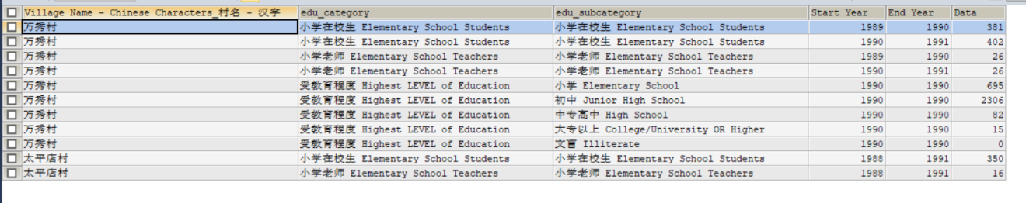

Discussion Point: any issue with our handling of year and year range?